

**PROJECT REPORT ON**

**SIGN LANGUAGE DETECTION USING MACHINE LEARNING**

**Submitted to**

Department of Computer Application  
in partial fulfillment for the award of the degree of

**MASTER’S OF COMPUTER APPLICATIONS**

Batch (2023-2025)

**Submitted by**

Name of the student: NIHARIKA SINGH  
Enrolment Number: GE-20211890

**Under the Guidance of**  
MISS. AYUSHI DWIVEDI

ASSISSTANT PROFESSOR

Graphic Era (Deemed to be) University  
DECEMBER – 2024



**CANDIDATE’S DECLARATION**

I hereby certify that the work presented in this project report entitled “**SIGN LANGUAGE DETECTION USING MACHINE LEARNING”** in partial fulfillment of the requirements for the award of the degree of Master’s of Computer Applications is a bonafide work carried out by me during the period of AUG 2024 to DEC 2024 under the supervision of Assisstant Professor Miss. Ayushi Dwivedi, Department of Computer Application, Graphic Era Deemed to be University, Dehradun, India.

This work has not been submitted elsewhere for the award of a degree/diploma/certificate.

**NIHARIKA SINGH**  
Name of Candidate



**Acknowledgment**

Every project begins with an idea and materializes with concrete efforts. In the beginning, I would like to thank the almighty God Who gave the strength and capabilities to work on this project and complete it successfully.

I would like to express my profound gratitude to Miss Ayushi Dwivedi Assisstant Professor, Department of Computer Application, for their immense support and valuable guidance during this project.

**NIHARIKA SINGH**  
Candidate Name



**CERTIFICATE OF ORIGINALITY**

This is to certify that the project report entitled “**SIGN LANGUAGE DETECTION USING MACHINE LEARNING**” submitted to Graphic Era University, Dehradun, in partial fulfillment of the requirement for the award of the degree of MASTER’S OF COMPUTER APPLICATIONS (MCA), is an authentic and original work carried out by Mr. NIHARIKA SINGH with enrollment number GE-20211890 under my supervision and guidance.

The matter embodied in this project is genuine work done by the student and has not been submitted to this University or any other University/Institute for the fulfillment of the requirements of any course of study.

Signature of the Head Of The Department Signature of the Guide

Date: Date:  
  
  
Signature of the Student:  
Enrollment No:

Name and Address of the student Name and Address of the Guide:

Special Note:

**Table of Contents**

**Chapter 1. Introduction**  
1.1 Project introduction — 7  
1.2 Objective — 8  
1.3 Scope — 9  
1.4 Hardware and Software requirement — 11-12

**Chapter 2. System analysis & requirement**  
2.1 Data flow diagram — 13  
2.2 Entity relation diagram — 15  
2.3 Architecture — 16

**Chapter 3. System design**  
3.1 Algorithms — 20

**Chapter 4. Project management**  
4.1 Project development approach — 25  
4.2 Project plan — 26  
4.3 Risk identification — 27  
4.4 Risk analysis — 28  
4.5 Risk planning — 29  
4.6 Cost estimation — 30

**Chapter 5. Input design — 31**  
**Chapter 6. Output design — 37**  
**Chapter 7. Future scope — 47**

**References / Bibliography — 48**

**CHAPTER 1 – INTRODUCTION**

* 1. **PROJECT INTRODUCTION**

Communication is a fundamental aspect of human interaction, enabling the exchange of thoughts, emotions, and ideas. For individuals with hearing or speech impairments, sign language serves as an indispensable mode of communication. It is a visual language that employs hand gestures, facial expressions, and body movements to convey meaning. However, the widespread adoption of sign language is hindered by the lack of universal understanding among non-signers, creating a significant communication barrier. This limitation underscores the pressing need for intelligent systems that can detect, recognize, and translate sign language into spoken or written text, fostering inclusivity and accessibility for all.

Advancements in machine learning (ML) and deep learning (DL) have opened new horizons for developing robust systems capable of understanding sign language. These systems can bridge the communication divide by automating the recognition and interpretation of sign gestures. However, existing approaches often face significant challenges. The diversity of sign languages across regions, individual variations in gestures, complex hand movements, and environmental factors such as lighting, background noise, and occlusion can all degrade the performance of traditional recognition models. To overcome these obstacles, a hybrid model-based approach that combines multiple machine learning techniques offers a promising solution for accurate and reliable sign language detection.

Sign language recognition involves processing complex spatiotemporal data encompassing hand shapes, motion trajectories, and facial expressions. Relying on a single model often fails to capture the intricacies of this multidimensional data effectively. Hybrid models, which integrate complementary strengths of different algorithms, can address these challenges by achieving higher accuracy, robustness, and adaptability.

For instance, a hybrid system may combine convolutional neural networks (CNNs) for extracting spatial features from images or videos with recurrent neural networks (RNNs) or Long Short-Term Memory (LSTM) networks for modeling temporal dependencies in sequential gestures. Additionally, transformer-based architectures like Vision Transformers (ViTs) can be integrated to handle spatial and temporal features simultaneously.

* 1. **OBJECTIVE**

The primary objective of this project is to develop a comprehensive and accurate hybrid machine learning model for real-time sign language detection and recognition. The system aims to:

• **Develop Accurate Sign Language Detection**: Create a hybrid machine learning system that recognizes and translates sign language gestures into spoken or written text with high accuracy.

• **Support Multiple Sign Languages**: Build a system that can handle diverse sign languages, including American Sign Language (ASL), British Sign Language (BSL), and regional dialects.

• **Enable Real-Time Recognition**: Ensure the system operates in real-time, providing immediate feedback and translation for seamless communication.

• **Integrate Spatial and Temporal Data**: Combine spatial features like hand shapes and body postures with temporal data from dynamic gestures for comprehensive recognition.

• **Enhance System Robustness**: Train the system to work reliably in diverse environmental conditions, including varying lighting, backgrounds, and partial occlusion.

• **Design User-Friendly Interfaces**: Develop an intuitive interface that allows users from all backgrounds to easily interact with the system.

• **Provide Multi-Modal Outputs**: Translate detected gestures into both text and speech formats to facilitate communication with non-signers.

• **Optimize for Scalability**: Create a flexible framework that can be scaled to recognize additional sign languages or gestures with minimal retraining.

• **Ensure Cross-Platform Compatibility**: Deploy the system across multiple devices, including smartphones, desktops, and IoT platforms, for widespread accessibility.

• **Promote Inclusivity and Accessibility**: Use the system to bridge communication gaps, empowering individuals with hearing and speech impairments and fostering a more inclusive society.

* 1. **SCOPE**

1. **Comprehensive Gesture Recognition**:  
   Develop a system capable of accurately recognizing both static and dynamic gestures, including hand shapes, movements, facial expressions, and body postures.
2. **Real-Time Translation**:  
   Ensure the system processes gestures and provides corresponding translations in text or speech formats instantaneously, enabling seamless communication.
3. **Support for Multiple Sign Languages**:  
   Extend support to various sign languages such as ASL, BSL, and other regional dialects, ensuring inclusivity and usability across different communities.
4. **Hybrid Machine Learning Models**:  
   Utilize a combination of CNNs, RNNs/LSTMs, and transformers to integrate spatial and temporal features for robust and accurate gesture recognition.
5. **Environmental Adaptability**:  
   Build a system that functions effectively under diverse conditions, including varying lighting, backgrounds, and levels of noise or occlusion.
6. **Cross-Platform Compatibility**:  
   Deploy the solution across multiple platforms, including web applications, mobile devices (iOS and Android), and IoT devices for broad accessibility.
7. **Customizability and Scalability**:  
   Design a framework that can be easily expanded to include additional gestures, languages, or features by updating datasets and retraining models.
8. **Assistive Tool for Various Applications**:  
   Implement the system in sectors like education, healthcare, public services, and workplaces to bridge communication gaps and foster inclusivity.
9. **User-Friendly Interface**:  
   Create an intuitive interface that enables easy interaction, requiring minimal training for both sign language users and non-signers.
10. **Performance Evaluation and Continuous Improvement**:  
    Regularly evaluate the system’s performance using metrics like accuracy, precision, and F1-score, while integrating user feedback for iterative improvements.
11. **Advanced Data Augmentation**:  
    Implement data augmentation techniques such as rotation, scaling, and flipping to increase the diversity of the training dataset, ensuring better generalization across different users and environments.
12. **User-Specific Adaptation**:  
    Integrate a feature that allows the system to adapt and personalize recognition for different users based on their unique signing style, improving recognition accuracy and user experience.
13. **Multimodal Communication**:  
    Extend the system’s capabilities to include voice and text-to-speech synthesis, enabling users to speak through the system and create a more interactive communication experience.
14. **Integration with Smart Devices**:  
    Ensure compatibility with smart devices such as smart TVs, voice-activated assistants, and smart home systems, allowing users to control devices through sign language.
15. **Learning and Training Mode**:  
    Include a training module within the system to help non-signers learn basic sign language gestures by practicing in real-time and receiving feedback.
16. **Automatic Gesture Segmentation**:  
    Develop methods for segmenting continuous sign language gestures accurately, which will be essential for parsing longer sentences or conversations.
17. **Emotion Detection**:  
    Integrate emotion detection algorithms to capture the emotional context of gestures, adding a layer of depth to translations and making interactions more natural and empathetic.
18. **Cloud-Based Analytics Dashboard**:  
    Create an analytics dashboard for users and educators to track progress, analyze usage data, and gain insights into common gestures and phrases.
19. **Open-Source Community Contribution**:  
    Release the project as an open-source initiative to encourage community contributions, facilitating continuous improvements and collaboration from developers worldwide.
20. **Support for Offline Functionality**:  
    Develop offline capabilities for the system to function without an internet connection, making it accessible for use in remote areas or situations where connectivity is limited.

* 1. **HARDWARE AND SOFTWARE REQUIREMENT**

#### **Hardware Requirements**

1. **Processor**:
   * A multi-core processor, such as Intel Core i7 or AMD Ryzen 7 (or higher), to handle computational tasks efficiently, including model training and real-time detection.
2. **Memory (RAM)**:
   * At least 16 GB of RAM for smooth data processing and handling large datasets during training and testing phases.
3. **Storage**:
   * A minimum of 512 GB SSD for fast data access and storage of models, with an additional HDD (1 TB or more) for datasets and backups.
4. **Graphics Processing Unit (GPU)**:
   * A high-performance GPU, such as NVIDIA RTX 2070 or higher with CUDA support, for accelerating deep learning model training and real-time inference.

#### **Software Requirements**

1. **Operating System**:
   * Windows 10/11, macOS, or a Linux distribution (e.g., Ubuntu 20.04) compatible with machine learning libraries and frameworks.
2. **Programming Languages**:
   * Python (version 3.7 or higher) for developing, training, and deploying machine learning models.
3. **Machine Learning Libraries and Frameworks**:
   * **TensorFlow** or **PyTorch** for building and training hybrid models.
   * **OpenCV** for image and video processing.
   * **Scikit-learn** for traditional machine learning tasks and evaluation metrics.
4. **Development Tools**:
   * **Jupyter Notebook** for interactive coding and visualization.
   * **Anaconda** for managing Python environments and dependencies.
   * **Git/GitHub** for version control and collaborative development.
   1. **LIBRARIES AND FRAMEWORK**

#### **1. Programming Languages**

* **Python (3.7 or higher)**: The primary language for machine learning and deep learning development.

#### **2. Development Environments**

* **VS Code**: An integrated development environment that provides extensive support for Python coding, debugging, and version control.
* **Google Colab**: A cloud-based platform that allows for easy collaboration and access to free GPUs for model training and testing.
* **Jupyter Notebook**: Ideal for interactive coding, data exploration, and visualization, making it great for prototyping and testing algorithms.
* **Roboflow**: A platform for managing computer vision datasets, including data annotation, augmentation, and preprocessing, as well as model training and deployment.

#### **3. Machine Learning Libraries**

* **TensorFlow** and **Keras**: Used for building and training deep learning models, including CNNs, RNNs, and hybrid architectures.
* **PyTorch**: An alternative to TensorFlow, known for its dynamic computational graph and ease of use in research and prototyping.
* **scikit-learn**: Useful for traditional machine learning models, preprocessing, and evaluation metrics.
* **OpenCV**: Essential for image and video processing, feature extraction, and real-time computer vision tasks.

#### **4. Computer Vision Libraries**

* **MediaPipe**: Effective for real-time hand tracking and gesture recognition, ideal for sign language detection applications.
* **Detectron2**: A robust framework for object detection and segmentation that can be adapted for recognizing complex hand gestures.
* **Matplotlib** and **Seaborn**: For data visualization and analysis to help understand training progress and model performance.

#### **5. Data Annotation and Management Tools**

* **Roboflow**: Provides data augmentation, annotation tools, and model training management. It's helpful for creating and maintaining a diverse dataset for sign language recognition.
* **LabelImg**: An alternative tool for manual data annotation if you need to label custom datasets.

#### **6. Additional Frameworks and Tools**

* **Hugging Face Transformers**: For integrating transformer-based models if you want to experiment with Vision Transformers (ViTs) or other pre-trained models for better handling of spatial and temporal features.
* **FastAPI**: For developing and deploying REST APIs for real-time sign language detection and integration with web or mobile applications.
* **Flask**: A lightweight web framework for building simple applications and deploying ML models with a user interface.

#### **7. Utilities for Data Preprocessing**

* **NumPy**: Essential for numerical operations and data manipulation.
* **Pandas**: Useful for handling datasets, preprocessing, and data analysis.
* **Albumentations**: A library for advanced data augmentation techniques to improve model generalization.

This combination of libraries and frameworks will enable efficient development, training, and deployment of your sign language detection system, ensuring that it operates reliably across different platforms and environments.

### 2. System Analysis & Requirements for Sign Language Detection Using Machine Learning

#### **1. System Analysis Overview**

The goal of this system analysis is to create a comprehensive understanding of the components, interactions, and technical requirements necessary for developing an effective sign language detection system. This involves analyzing the input and output requirements, processing workflow, data flow, and essential interactions between the system’s modules.

#### **2. Functional Requirements**

These are the core functionalities that the sign language detection system must support:

* **Gesture Detection and Recognition**: The system should be able to recognize and interpret hand gestures and movements in real-time from video input.
* **Multilingual Support**: The system must support multiple sign languages (e.g., ASL, BSL) and potentially allow for easy integration of additional languages.
* **Real-Time Processing**: The system should have low-latency processing to enable real-time recognition and translation.
* **Text and Audio Output**: The recognized gestures should be converted into text and, optionally, speech for easy understanding.
* **User Feedback**: Provide feedback to users to improve accuracy and learning.
* **Data Storage and Management**: The system should have capabilities for storing and managing large datasets for training, validation, and testing.
* **Interactive User Interface**: An intuitive and user-friendly interface to facilitate interactions with non-experts.

#### **3. Non-Functional Requirements**

These requirements ensure that the system meets quality standards beyond its functional capabilities:

* **Performance**: The system must be optimized to handle large video data streams efficiently, with real-time processing.
* **Scalability**: The system should be scalable to accommodate increased data load and new sign languages.
* **Reliability**: Ensure minimal downtime and robust performance under different environmental conditions.
* **Security**: Implement user data privacy and system security to prevent unauthorized access and data breaches.
* **Usability**: The system should have a simple and accessible interface, especially for users who may not be familiar with advanced technology.
* **Maintainability**: Design the system for easy updates and troubleshooting. Modular code and documentation should be maintained for ease of future development.
* **Compatibility**: The system should be compatible with various platforms such as Windows, macOS, Android, iOS, and web applications.

#### **4. Data Requirements**

* **Input Data**: Video data containing hand movements and gestures, which can be recorded using webcams or specialized cameras.
* **Dataset Specifications**: A diverse dataset that includes various sign language gestures, expressions, and environmental conditions.
* **Data Annotation**: High-quality, labeled data to train the machine learning models. This can be achieved through tools like Roboflow for labeling and augmentation.

#### **5. System Architecture**

The system should follow a modular architecture that includes the following components:

* **Data Collection Module**: Captures real-time video input from cameras or uploaded video files.
* **Preprocessing Module**: Performs data preprocessing such as noise reduction, frame normalization, and background removal.
* **Feature Extraction Module**: Uses deep learning models (e.g., CNNs, ViTs) to extract features from video frames.
* **Recognition Module**: Integrates RNNs or LSTMs for processing temporal sequences to recognize sign language gestures.
* **Translation Module**: Converts recognized gestures into text and/or speech using NLP and TTS (Text-to-Speech) technologies.
* **User Interface (UI)**: A front-end interface for interaction, which could be web-based or a mobile app.
* **Storage and Database**: A backend for managing data storage, including training data, model versions, and user data.
* **API Layer**: An optional RESTful API layer using **FastAPI** or **Flask** for integration with other applications.

#### **6. Technical Requirements**

* **Programming Languages**: Python for building and training machine learning models, JavaScript for web development, and Swift/Kotlin for mobile app development.
* **Libraries and Frameworks**:
  + **Machine Learning**: TensorFlow, PyTorch, Scikit-learn.
  + **Computer Vision**: OpenCV, MediaPipe, Detectron2.
  + **Web Frameworks**: Flask, FastAPI, React for the front end.
  + **Data Processing**: Pandas, NumPy, Albumentations for data augmentation.
  + **Visualization**: Matplotlib, Seaborn for analyzing model performance.
* **Hardware**:
  + High-performance CPU (e.g., Intel i7 or AMD Ryzen 7).
  + GPU with CUDA support (e.g., NVIDIA GTX 1080 or higher).
  + 16 GB or more of RAM.
  + SSD storage (minimum 512 GB) for data and model storage.
* **Software**:
  + Operating Systems: Windows, macOS, or Linux.
  + Development Environments: VS Code, Jupyter Notebook, Google Colab for training and prototyping.
  + Version Control: Git for source code management.

#### **7. Security and Privacy Requirements**

* **Data Encryption**: Encrypt sensitive data during transmission and storage.
* **User Authentication**: Implement secure login systems to protect user data and settings.
* **Compliance**: Ensure compliance with data privacy regulations such as GDPR for user data handling.

#### **8. Performance Metrics**

* **Accuracy**: Measure the precision of gesture recognition.
* **Latency**: Assess the system’s response time for real-time processing.
* **Processing Speed**: Evaluate the speed of video input processing, feature extraction, and gesture translation.
* **User Feedback and Satisfaction**: Collect and analyze user feedback to continually improve system usability and effectiveness.

#### **9. Potential Challenges**

* **Data Quality**: Ensuring a high-quality and diverse dataset to train robust models.
* **Model Complexity**: Balancing model complexity to achieve high performance without excessive computation.
* **Environmental Factors**: Handling variations in lighting, background noise, and occlusions.
* **User Adaptability**: Ensuring that the system is easy to use for non-technical users and has an intuitive interface.

**2.1 DATA FLOW DIAGRAM**

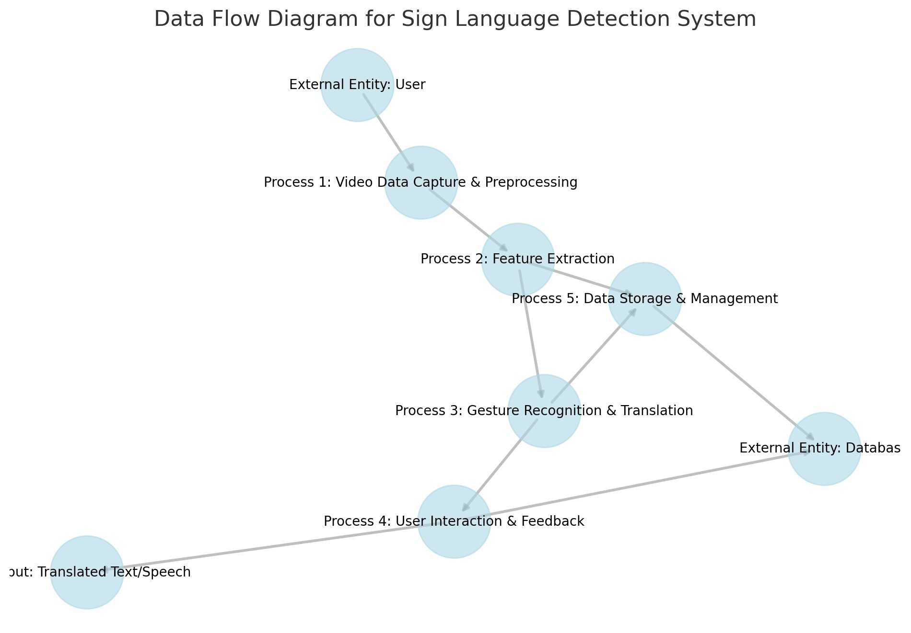

**2.2** Entity relation diagram

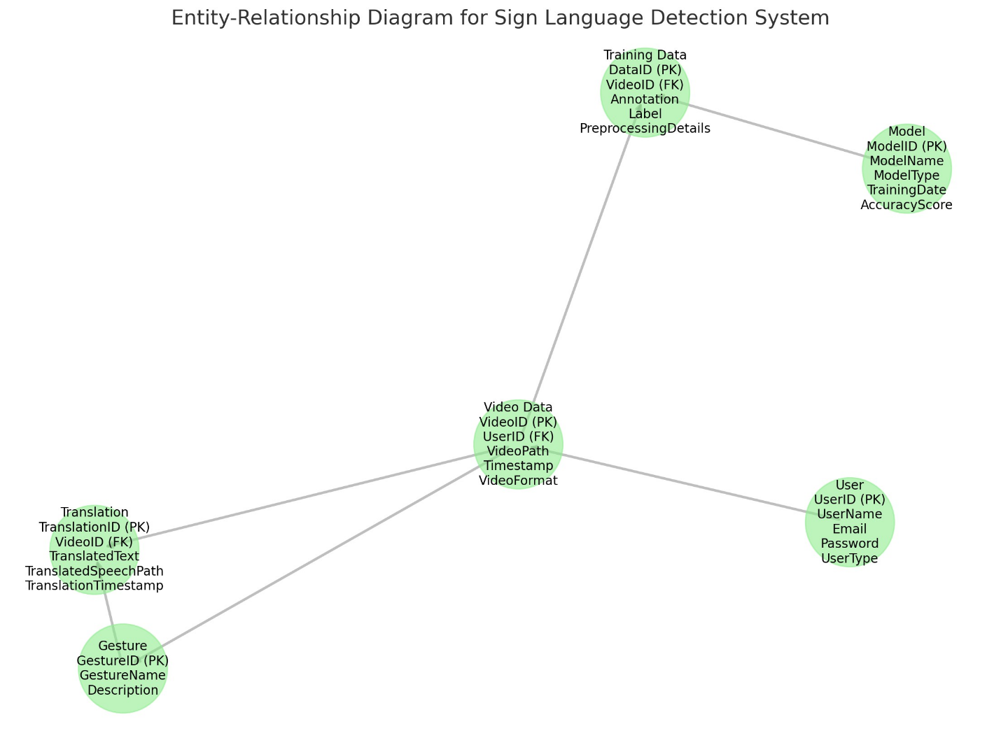

**Entities** include **User**, **Video Data**, **Gesture**, **Translation**, **Model**, and **Training Data**.

**Attributes** are shown for each entity, with primary keys (PK) and foreign keys (FK) identified to illustrate relationships.

**Relationships** between entities:

* **User** can upload **Video Data** (1-to-many).
* **Video Data** can contain **Gestures** and be associated with **Translations** (1-to-many).
* **Model** is trained using **Training Data** (1-to-many).
* **Gesture** can be part of **Translations** (1-to-many).
* **Video Data** can be used for **Training Data** (1-to-many).

**2.3 ARCHITECTURE**

#### **1. System Architecture Overview**

The system can be structured using a **multi-layered architecture** approach, typically involving the following layers:

* **Data Collection and Preprocessing Layer**
* **Feature Extraction and Model Inference Layer**
* **Application Layer (User Interface)**
* **Data Storage and Management Layer**

#### **2. Architecture Components**

##### **1. Data Collection and Preprocessing Layer**

* **Video Capture Module**:
  + **Function**: Captures real-time video input from cameras or allows for the upload of pre-recorded video files.
  + **Technologies**: OpenCV for video streaming and manipulation, MediaPipe for hand tracking.
* **Preprocessing Module**:
  + **Function**: Processes video frames to remove noise, normalize images, and perform background subtraction.
  + **Technologies**: Python libraries like OpenCV, NumPy, and custom image processing algorithms.

##### **2. Feature Extraction and Model Inference Layer**

* **Feature Extraction Module**:
  + **Function**: Extracts spatial features from video frames (e.g., hand shape and posture) and temporal features (e.g., movement and gesture flow).
  + **Technologies**: Convolutional Neural Networks (CNNs) for spatial feature extraction; Recurrent Neural Networks (RNNs) or Long Short-Term Memory (LSTM) networks for temporal processing.
* **Model Inference Module**:
  + **Function**: Uses trained models to recognize gestures and map them to specific sign language vocabulary.
  + **Technologies**: TensorFlow or PyTorch for deep learning model execution; pre-trained models for transfer learning if needed.

##### **3. Application Layer (User Interface)**

* **User Interface (UI)**:
  + **Function**: Provides an interface for users to interact with the system, upload videos, view translations, and receive feedback.
  + **Technologies**: Web applications built with frameworks like Flask, FastAPI, or React for interactive user experience; mobile applications using React Native, Swift, or Kotlin.
* **Interaction Module**:
  + **Function**: Displays real-time translations and outputs (text and speech). Provides interactive features for users to practice and receive feedback.
  + **Technologies**: JavaScript, WebSockets for real-time interaction, Text-to-Speech (TTS) libraries for audio output.

##### **4. Data Storage and Management Layer**

* **Database**:
  + **Function**: Stores user data, video recordings, processed gesture data, and training datasets.
  + **Technologies**: SQL databases (e.g., PostgreSQL, MySQL) or NoSQL databases (e.g., MongoDB) for scalability and flexibility.
* **Cloud Storage**:
  + **Function**: For storing large video datasets and processed training data.
  + **Technologies**: AWS S3, Google Cloud Storage, Azure Blob Storage.
* **Model Management**:
  + **Function**: Stores and manages trained models, version control for updates, and continuous integration for new models.
  + **Technologies**: Model management tools like MLflow or TensorFlow Model Serving.

#### **3. System Workflow**

1. **Video Input**: The user provides video data through a webcam or uploads pre-recorded files.
2. **Preprocessing**: The system processes the video frames, cleans and normalizes them, and extracts relevant features.
3. **Feature Extraction**: The extracted features are sent to the model inference module for gesture recognition.
4. **Gesture Recognition and Translation**:
   * The model identifies the gesture and maps it to the corresponding sign language.
   * Translations are generated as text and/or speech.
5. **Output Display**: The results are displayed to the user through the UI. This may include text translations, audio output, and interactive feedback.
6. **Feedback and Interaction**: Users can provide feedback, which helps improve the system's accuracy over time.
7. **Data Storage**: Video data, recognition results, and feedback are stored for future analysis and training updates.

#### **4. High-Level Architecture Diagram**

While I can describe how to visualize this architecture, creating a high-level diagram requires diagramming tools. Here's how you might structure it:

1. **Data Collection Layer**: Includes video input and preprocessing blocks.
2. **Feature Extraction and Inference Layer**: Includes feature extraction, model inference, and gesture recognition.
3. **Application Layer**: Includes user interface components and interaction modules.
4. **Storage Layer**: Includes databases and cloud storage for managing data and models.

**3. SYSTEM DESIGN**

#### **1. System Design Overview**

The system is designed to process video input, detect and recognize hand gestures, translate them into text or speech, and present the output to users through an interactive interface. The design incorporates modular components to facilitate ease of use, scalability, and future improvements.

#### **2. System Components and Architecture**

##### **1. Data Collection and Input Layer**

* **Video Capture Module**:
  + Captures real-time video streams from a camera or allows users to upload pre-recorded video files.
  + **Technologies**: OpenCV for video streaming and recording; MediaPipe for real-time hand tracking and pose estimation.
* **Preprocessing Module**:
  + Prepares video frames by removing noise, normalizing them, resizing to a fixed resolution, and applying background subtraction techniques.
  + **Technologies**: OpenCV, NumPy for image processing, and custom-built scripts for background removal and frame normalization.

##### **2. Feature Extraction and Model Inference Layer**

* **Feature Extraction Module**:
  + Extracts spatial features from each frame (e.g., hand shape and posture) using CNN architectures.
  + Temporal features (e.g., movement and gesture sequences) are processed using RNNs or LSTMs to capture gesture flow.
  + **Technologies**: TensorFlow or PyTorch for building CNNs, LSTMs, and hybrid deep learning models.
* **Gesture Recognition and Translation Module**:
  + The trained model processes the extracted features to identify and classify gestures.
  + Translates recognized gestures into text or audio using a pre-trained NLP model and Text-to-Speech (TTS) systems.
  + **Technologies**: Pre-trained models like BERT or custom NLP models for translation; TTS libraries like Google Text-to-Speech (gTTS) for audio output.

##### **3. User Interface (UI) Layer**

* **Web and Mobile Applications**:
  + Provides an interface for users to interact with the system, upload video data, and view results.
  + **Technologies**: React.js or Vue.js for web applications; React Native, Swift, or Kotlin for mobile applications.
* **Interaction Module**:
  + Displays real-time feedback, translated text, and audio output.
  + Allows users to provide feedback on accuracy and performance.
  + **Technologies**: WebSockets for real-time data updates and JavaScript for interactive UI elements.

##### **4. Data Storage and Management Layer**

* **Database System**:
  + Stores user data, video files, processed gesture data, and system feedback.
  + **Technologies**: SQL databases (e.g., PostgreSQL, MySQL) or NoSQL databases (e.g., MongoDB) for structured and unstructured data storage.
* **Cloud Storage**:
  + Handles the storage of large video datasets and processed data.
  + **Technologies**: AWS S3, Google Cloud Storage, or Azure Blob Storage for scalable and secure data storage.
* **Model Management**:
  + Stores and versions machine learning models for training and deployment.
  + **Technologies**: MLflow or TensorFlow Model Serving for model tracking and deployment.

#### **3. Workflow and Interaction Diagram**

The workflow outlines how data flows through the system, starting from video capture and preprocessing to output display and storage:

1. **Video Input**:
   * The user uploads a video or uses a live webcam feed.
2. **Preprocessing**:
   * The video data undergoes normalization, noise reduction, and background subtraction.
3. **Feature Extraction**:
   * Spatial and temporal features are extracted from processed video frames.
4. **Gesture Recognition**:
   * Features are fed into a trained deep learning model for gesture classification.
5. **Translation and Output**:
   * The recognized gestures are translated into text and/or speech.
6. **Display and User Interaction**:
   * Translations are displayed on the UI in real-time, along with audio feedback.
7. **Feedback Collection**:
   * User feedback is collected and stored for system improvement.

#### **4. System Design Diagram**

Below is a textual outline of how the components interact:

1. **User** → **Video Capture Module** → **Preprocessing Module**
2. **Preprocessed Video Frames** → **Feature Extraction Module**
3. **Extracted Features** → **Gesture Recognition and Translation Module**
4. **Translated Text/Speech** → **User Interface (UI)**
5. **User Feedback** → **Feedback Collection and Storage**
6. **Model Management** (interacts with **Training Data** for updates)

**3.1 ALGORITHM**

#### **Data Collection and Preparation**

* **Step 1**: Collect a dataset of labeled sign language images or videos.
* **Step 2**: Use tools like Roboflow to annotate and format the dataset in YOLO-compatible format.
* **Step 3**: Download the dataset and organize it with appropriate directories for training (e.g., /images and /labels).

#### **2. Model Training**

* **Step 4**: Install and set up necessary libraries (e.g., Ultralytics, Roboflow).
* **Step 5**: Load the YOLO pre-trained model (e.g., yolov8s.pt).
* **Step 6**: Set up the configuration file (data.yaml) that specifies the dataset paths, classes, and training parameters.
* **Step 7**: Train the model by running the training command with specified parameters (e.g., epochs, image size):

bash

Copy code

!yolo task=detect mode=train model=/path/to/yolov8s.pt data=/path/to/data.yaml epochs=30 imgsz=640

* **Step 8**: Monitor the training process and save the best model weights (e.g., best.pt).

#### **3. Saving and Exporting the Model**

* **Step 9**: Copy the best-trained model to a cloud storage or local directory for backup.
* **Step 10**: Create a zip file containing the trained model for easier download and sharing:

python

Copy code

import zipfile

with zipfile.ZipFile('best_model.zip', 'w') as zipf:

zipf.write('/path/to/best.pt', 'best.pt')

* **Step 11**: Download or move the zip file to a desired location (e.g., Google Drive, desktop).

#### **4. Model Inference and Testing**

* **Step 12**: Set up a local or cloud-based Python environment (e.g., VS Code, Google Colab).
* **Step 13**: Load the trained YOLO model for inference:

python

Copy code

model = YOLO("/path/to/best.pt")

* **Step 14**: Run the model on live video input (webcam) or static images:

python

Copy code

model.predict(source="0", show=True, conf=0.3)

* **Step 15**: Display real-time results with bounding boxes and confidence scores.

#### **5. User Interface and Interaction**

* **Step 16**: Design a web or mobile application to display the model's predictions.
* **Step 17**: Integrate the model with the application backend to process video streams or images in real-time.
* **Step 18**: Add feedback mechanisms for users to improve the system's performance over time.

#### **6. Data Storage and Model Management**

* **Step 19**: Store the processed data, predictions, and user feedback in a database for future analysis.
* **Step 20**: Maintain version control for models using tools like MLflow or cloud-based services for better management and updates.

#### **7. Continuous Improvement**

* **Step 21**: Collect user feedback and monitor the model’s performance.
* **Step 22**: Retrain the model with updated data or fine-tune it as needed to enhance accuracy and adapt to new sign language variations.

#### **Summary of the Algorithm**:

This algorithm covers data collection, model training, exportation, inference, user interaction, data management, and system improvements for building a sign language detection system using YOLO and machine learning.

**4, PROJECT MANAGEMENT**

Managing the development of a complex system like a **sign language detection platform** requires detailed planning, risk management, and comprehensive resource allocation. Here, I provide further elaboration on the project development approach, project planning, risk identification, risk analysis, risk planning, and cost estimation.

#### **4.1 Project Development Approach**

**Development Methodology**: The Agile methodology is chosen for its iterative approach, allowing teams to develop, test, and refine system components incrementally. This approach fosters adaptability and continuous integration of user feedback.

**Key Features of the Agile Approach**:

* **Iterative Development**: The project is broken down into manageable sprints, with deliverables at the end of each cycle.
* **Collaborative Work Environment**: Cross-functional teams including data scientists, developers, UI/UX designers, and project managers collaborate to ensure project milestones are met.
* **Incremental Delivery**: Features and functionalities are delivered in increments, allowing early access to certain capabilities and faster user feedback.
* **Continuous Feedback Loop**: End-user feedback is gathered during sprint reviews and used to adjust the project direction for future sprints.
* **Scalable Architecture**: The development process emphasizes designing a system that can scale as the project evolves or when more sign languages are added.

**Methodology Stages**:

1. **Sprint Planning**: Prioritize user stories and set sprint goals.
2. **Development & Coding**: Implement new features, test functionalities, and integrate models.
3. **Testing & Quality Assurance**: Conduct unit tests, integration tests, and user acceptance testing.
4. **Sprint Review**: Present the work completed during the sprint to stakeholders for feedback.
5. **Sprint Retrospective**: Discuss what went well, what could be improved, and set actionable items for the next sprint.

#### **4.2 Project Plan**

**Timeline and Phases**:

* **Phase 1: Requirement Gathering and Planning (2 weeks)**
  + Engage with stakeholders to outline project objectives and define scope.
  + Document system requirements, user stories, and feature specifications.
  + Establish clear success criteria and define the MVP (Minimum Viable Product).
* **Phase 2: Data Collection and Preprocessing (4 weeks)**
  + Collect diverse video datasets and ensure data annotations align with project needs.
  + Perform extensive preprocessing, including image normalization, noise reduction, and data augmentation.
  + Implement a data pipeline for seamless training data updates.
* **Phase 3: Model Architecture Design and Training (6 weeks)**
  + Design the model architecture based on YOLO and choose an appropriate version (e.g., YOLOv8).
  + Train the model on a high-performance GPU cluster to achieve optimal results.
  + Monitor training with visualization tools and adjust hyperparameters as needed.
* **Phase 4: UI Development and System Integration (4 weeks)**
  + Design and develop the user interface for web or mobile applications.
  + Integrate the trained model into the application backend using APIs.
  + Conduct user interface testing and make adjustments based on feedback.
* **Phase 5: Testing and Pre-Deployment (3 weeks)**
  + Conduct comprehensive system testing, including load tests, user acceptance tests, and security audits.
  + Prepare deployment scripts and perform a staged deployment.
  + Ensure that the system performs well under different network conditions and data input scenarios.
* **Phase 6: Deployment and Post-Launch Monitoring (Ongoing)**
  + Deploy the system to production, ensuring seamless user access.
  + Set up real-time monitoring tools to track system performance, detect anomalies, and collect user feedback.
  + Schedule periodic reviews for updates, security patches, and new feature integration.

**Milestones**:

* **Completion of Phase 1**: Requirement specification document.
* **Completion of Phase 2**: A fully annotated, cleaned, and augmented dataset.
* **Completion of Phase 3**: A trained and validated model ready for integration.
* **Completion of Phase 4**: A functional UI with basic interaction and feedback capabilities.
* **Completion of Phase 5**: A fully tested and pre-deployed system.
* **Completion of Phase 6**: Live deployment with continuous performance tracking.

#### **4.3 Risk Identification**

**Detailed Risk Categories**:

1. **Data Quality Risks**:
   * **Insufficient or Biased Data**: May lead to model biases and reduced accuracy.
   * **Inconsistent Data Annotations**: Can affect model training and performance.
2. **Technical Risks**:
   * **Hardware Limitations**: GPU failures or hardware crashes during training.
   * **Software Compatibility Issues**: Potential conflicts between libraries and frameworks.
3. **Human Resource Risks**:
   * **Skill Gaps**: Lack of experienced team members for specific aspects (e.g., deep learning optimization).
   * **High Turnover**: Loss of key team members affecting the timeline.
4. **Operational Risks**:
   * **Scalability Challenges**: System performance issues when scaling up to handle more users.
   * **Security Vulnerabilities**: Potential breaches affecting data privacy.
5. **Deployment and Post-Deployment Risks**:
   * **Downtime During Deployment**: Potential system outages during the deployment phase.
   * **Integration with Other Services**: Compatibility issues when linking with external APIs or services.

#### **4.4 Risk Analysis**

**Likelihood vs. Impact Matrix**:

* **High Probability, High Impact**:
  + **Data Quality Issues**: Addressed by rigorous data validation and augmentation strategies.
  + **Technical Challenges**: Solved with redundant hardware and backup models.
* **Medium Probability, High Impact**:
  + **Human Resource Challenges**: Solutions include cross-training team members and having backup personnel.
  + **Security Risks**: Mitigated through regular penetration tests and data encryption.
* **Low Probability, High Impact**:
  + **Deployment Downtime**: Minimized through pre-deployment testing and backup server infrastructure.
  + **Integration Challenges**: Managed with thorough documentation and API testing.

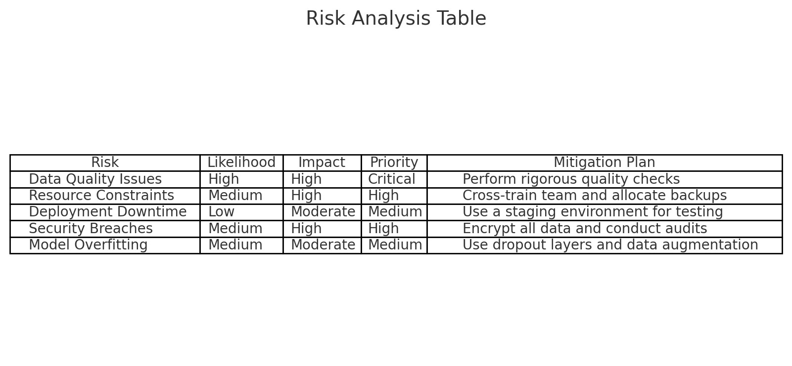

#### **4.5 Risk Planning**

**Comprehensive Risk Management Strategies**:

* **Preemptive Data Quality Management**: Regularly audit and clean datasets to maintain quality.
* **Hardware Preparedness**: Use cloud-based solutions for scalability and resource management.
* **Employee Training Programs**: Ensure the team receives training on the latest technologies to bridge any skill gaps.
* **Enhanced Security Measures**: Implement best practices for data encryption and two-factor authentication.
* **Detailed Deployment Plan**: Establish rollback mechanisms, conduct dry runs, and create a fallback plan for deployment.

**Contingency Plans**:

* **Data Backup**: Maintain regular backups of data, models, and system configurations.
* **Monitoring and Alerts**: Set up system alerts for anomalies during training and post-deployment.
* **Rollback Protocols**: Create procedures for reverting to the previous version if issues arise during deployment.

#### **4.6 Cost Estimation**

**Detailed Cost Breakdown**:

* **Personnel Costs**:
  + **Salaries**: Data scientists, software engineers, project managers, and QA testers ($60,000 - $120,000/year per team member).
  + **Contractors**: Part-time specialists for specific tasks (e.g., security audits, data annotation).
* **Hardware and Infrastructure Costs**:
  + **GPUs**: High-performance GPUs like NVIDIA RTX 3090 ($1,500 - $3,000 each).
  + **Cloud Services**: Costs for training and storage on cloud platforms like AWS, Google Cloud, or Azure ($2,000 - $10,000/month).
* **Software Costs**:
  + **Libraries**: Open-source tools like TensorFlow, PyTorch, and OpenCV are free. Premium services (e.g., Roboflow for data augmentation) may incur costs ($500 - $2,000/year).
  + **Development Tools**: IDEs, API services, and UI/UX design tools ($100 - $1,000/year).
* **Operational Costs**:
  + **Cloud Hosting and Maintenance**: $200 - $1,000/month for server and database services.
  + **Post-Launch Support**: Regular updates and system maintenance.
* **Contingency Budget**:
  + Allocate 10-15% of the total estimated budget for unexpected expenses.

**Estimated Total Budget**:

* **Small-Scale Project**: $70,000 - $150,000.
* **Medium-Scale Project**: $150,000 - $300,000.
* **Large-Scale Project**: $300,000 - $500,000+.

**Cost Management Strategies**:

* **Budget Reviews**: Conduct monthly budget assessments to ensure adherence to the planned expenses.
* **Resource Optimization**: Use cloud services only during peak training times and opt for cost-effective hardware where possible.

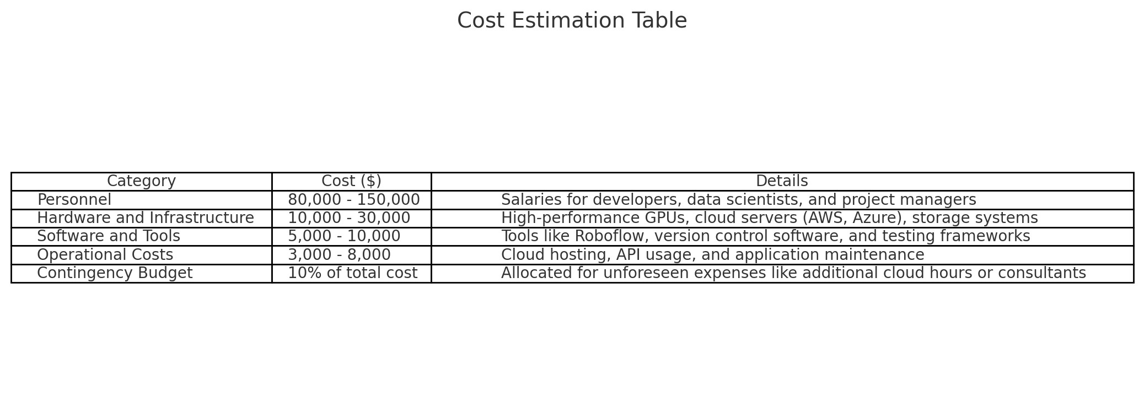

1. input design

#### **Installing and Importing Libraries**

python

Copy code

!nvidia-smi # Check GPU status and availability.

!pip install ultralytics # Install the Ultralytics package for YOLO.

from ultralytics import YOLO # Import the YOLO model.

import os

from IPython.display import display, Image, clear_output

clear_output() # Clear the Colab output.

!yolo checks # Verify YOLO installation.

!pip install roboflow # Install Roboflow for dataset management.

* **Purpose**: This section installs the necessary libraries, checks GPU availability, and clears the output for a cleaner workspace.

#### **Downloading and Preparing the Dataset**

python

Copy code

from roboflow import Roboflow

rf = Roboflow(api_key="weybJezBYVCQ2eiqFtb3") # Replace with your own API key.

project = rf.workspace("sign-language-detection-dmww4").project("sign-language-detection-1w7ye")

version = project.version(3)

dataset = version.download("yolov8")

* **Purpose**: Connects to Roboflow using an API key, retrieves the dataset for sign language detection, and downloads it in YOLO format.

#### **Training the YOLO Model**

python

Copy code

!yolo task=detect mode=train model=/content/yolov8s.pt data=/content/sign-language-detection-3/data.yaml epochs=30 imgsz=640

* **Purpose**: Starts the training process using the YOLO model with a specified pre-trained model (yolov8s.pt), data configuration file (data.yaml), 30 epochs, and an image size of 640 pixels.

#### **Mounting Google Drive and Copying Model**

python

Copy code

from google.colab import drive

import os

# Mount Google Drive to save the trained model.

drive.mount('/content/drive')

# Copy the best model weights to Google Drive.

source_path = '/content/runs/detect/train/weights/best.pt'

destination_path = 'C:\\Users\\ALOK\\OneDrive\\Desktop\\sign language detection'

!cp "{source_path}" "{destination_path}"

print(f"File copied to: C:\\Users\\ALOK\\OneDrive\\Desktop\\sign language detection")

* **Purpose**: Mounts Google Drive to save the best-trained model weights (best.pt) for future use or download.

#### **Creating a Zip File for the Model**

python

Copy code

from google.colab import files

import zipfile

# Create a zip file containing the best model.

best_pt_path = '/content/runs/detect/train/weights/best.pt'

zip_file_path = 'best_model.zip'

with zipfile.ZipFile(zip_file_path, 'w') as zipf:

zipf.write(best_pt_path, os.path.basename(best_pt_path))

# Download the zip file.

files.download(zip_file_path)

* **Purpose**: Zips the trained model weights and downloads it to the local system for offline use.

### 2. ****VS Code Code Explanation****

#### **Installing and Importing Libraries**

python

Copy code

import ultralytics

from ultralytics import YOLO

print("Ultralytics installed successfully!")

# Optional: Use OpenCV to test camera access.

import cv2

print("OpenCV installed successfully!")

* **Purpose**: Imports the necessary libraries for YOLO and OpenCV for camera access testing.

#### **Loading the Trained Model**

python

Copy code

model = YOLO("C:/Users/ALOK/OneDrive/Desktop/best.pt") # Load the trained model from the local path.

* **Purpose**: Loads the trained YOLO model from the specified path for inference.

#### **Camera Access Check Function**

python

Copy code

def check_imshow():

try:

assert not is_docker(),'cv2.imshow() is disabled in docker environments'

assert not is_colab(),'cv2.imshow() is disabled in google colab environments'

cv2.imshow('test', np.zeros((1, 1, 3)))

cv2.waitKey(1)

cv2.destroyAllWindows()

cv2.waitKey(1)

return True

except Exception as e:

print(f'WARNING: Environment does not support cv2.imshow() or PIL image')

return False

* **Purpose**: Checks if cv2.imshow() can be used in the current environment (useful for local machine testing).

#### **Running the Model for Inference**

python

Copy code

model.predict(source="0", show=True, conf=0.3) # Predict using the webcam (source="0"), show the output, and set confidence threshold.

* **Purpose**: Runs the model on a live webcam feed, displaying the output with a confidence threshold of 0.3.

1. output design

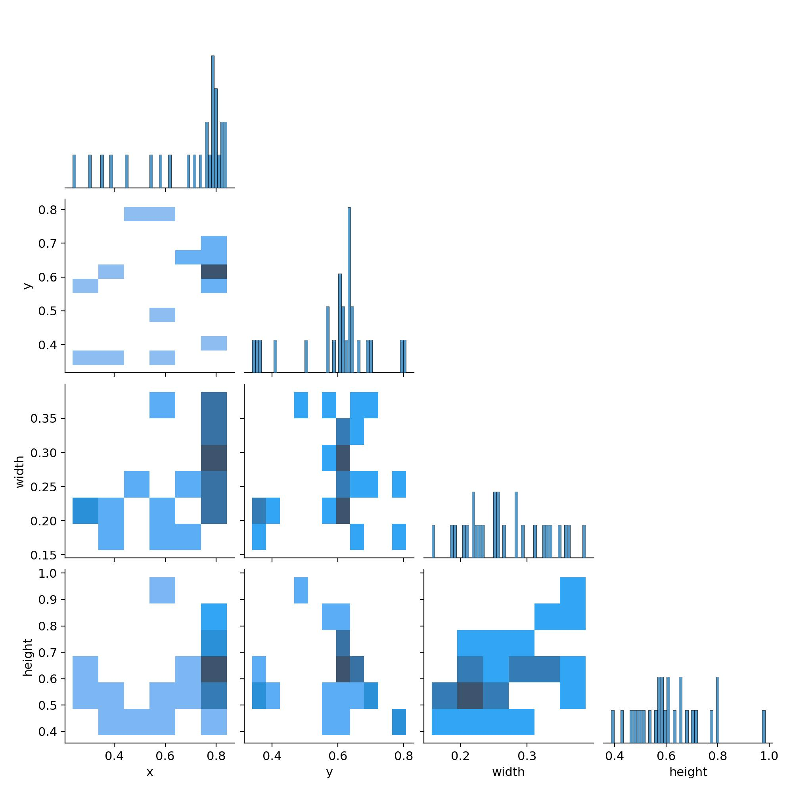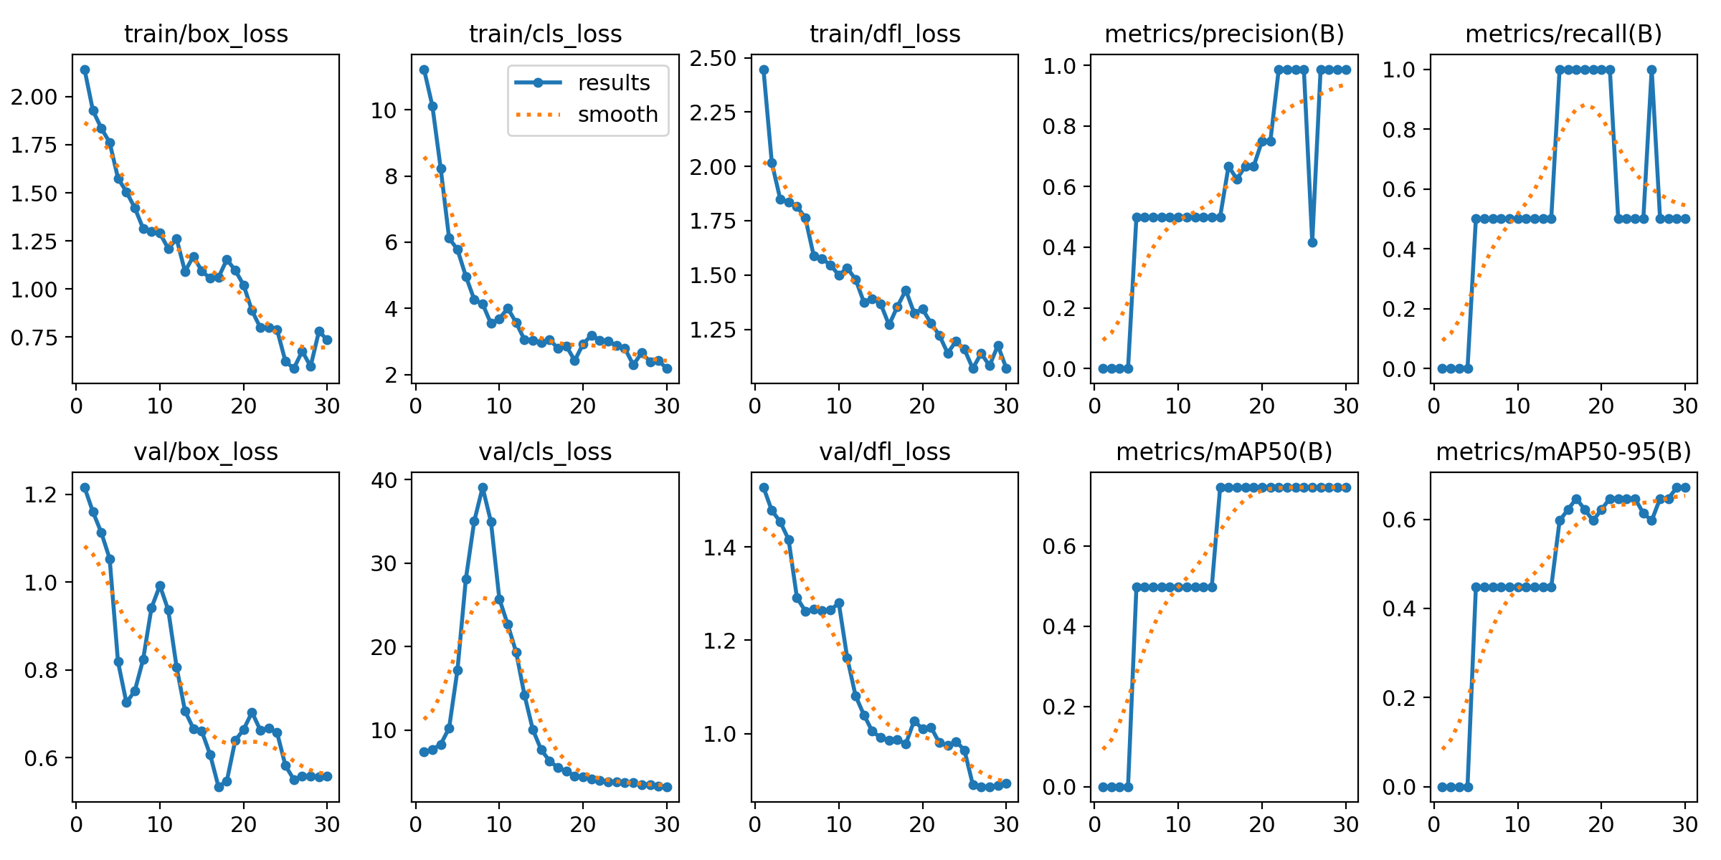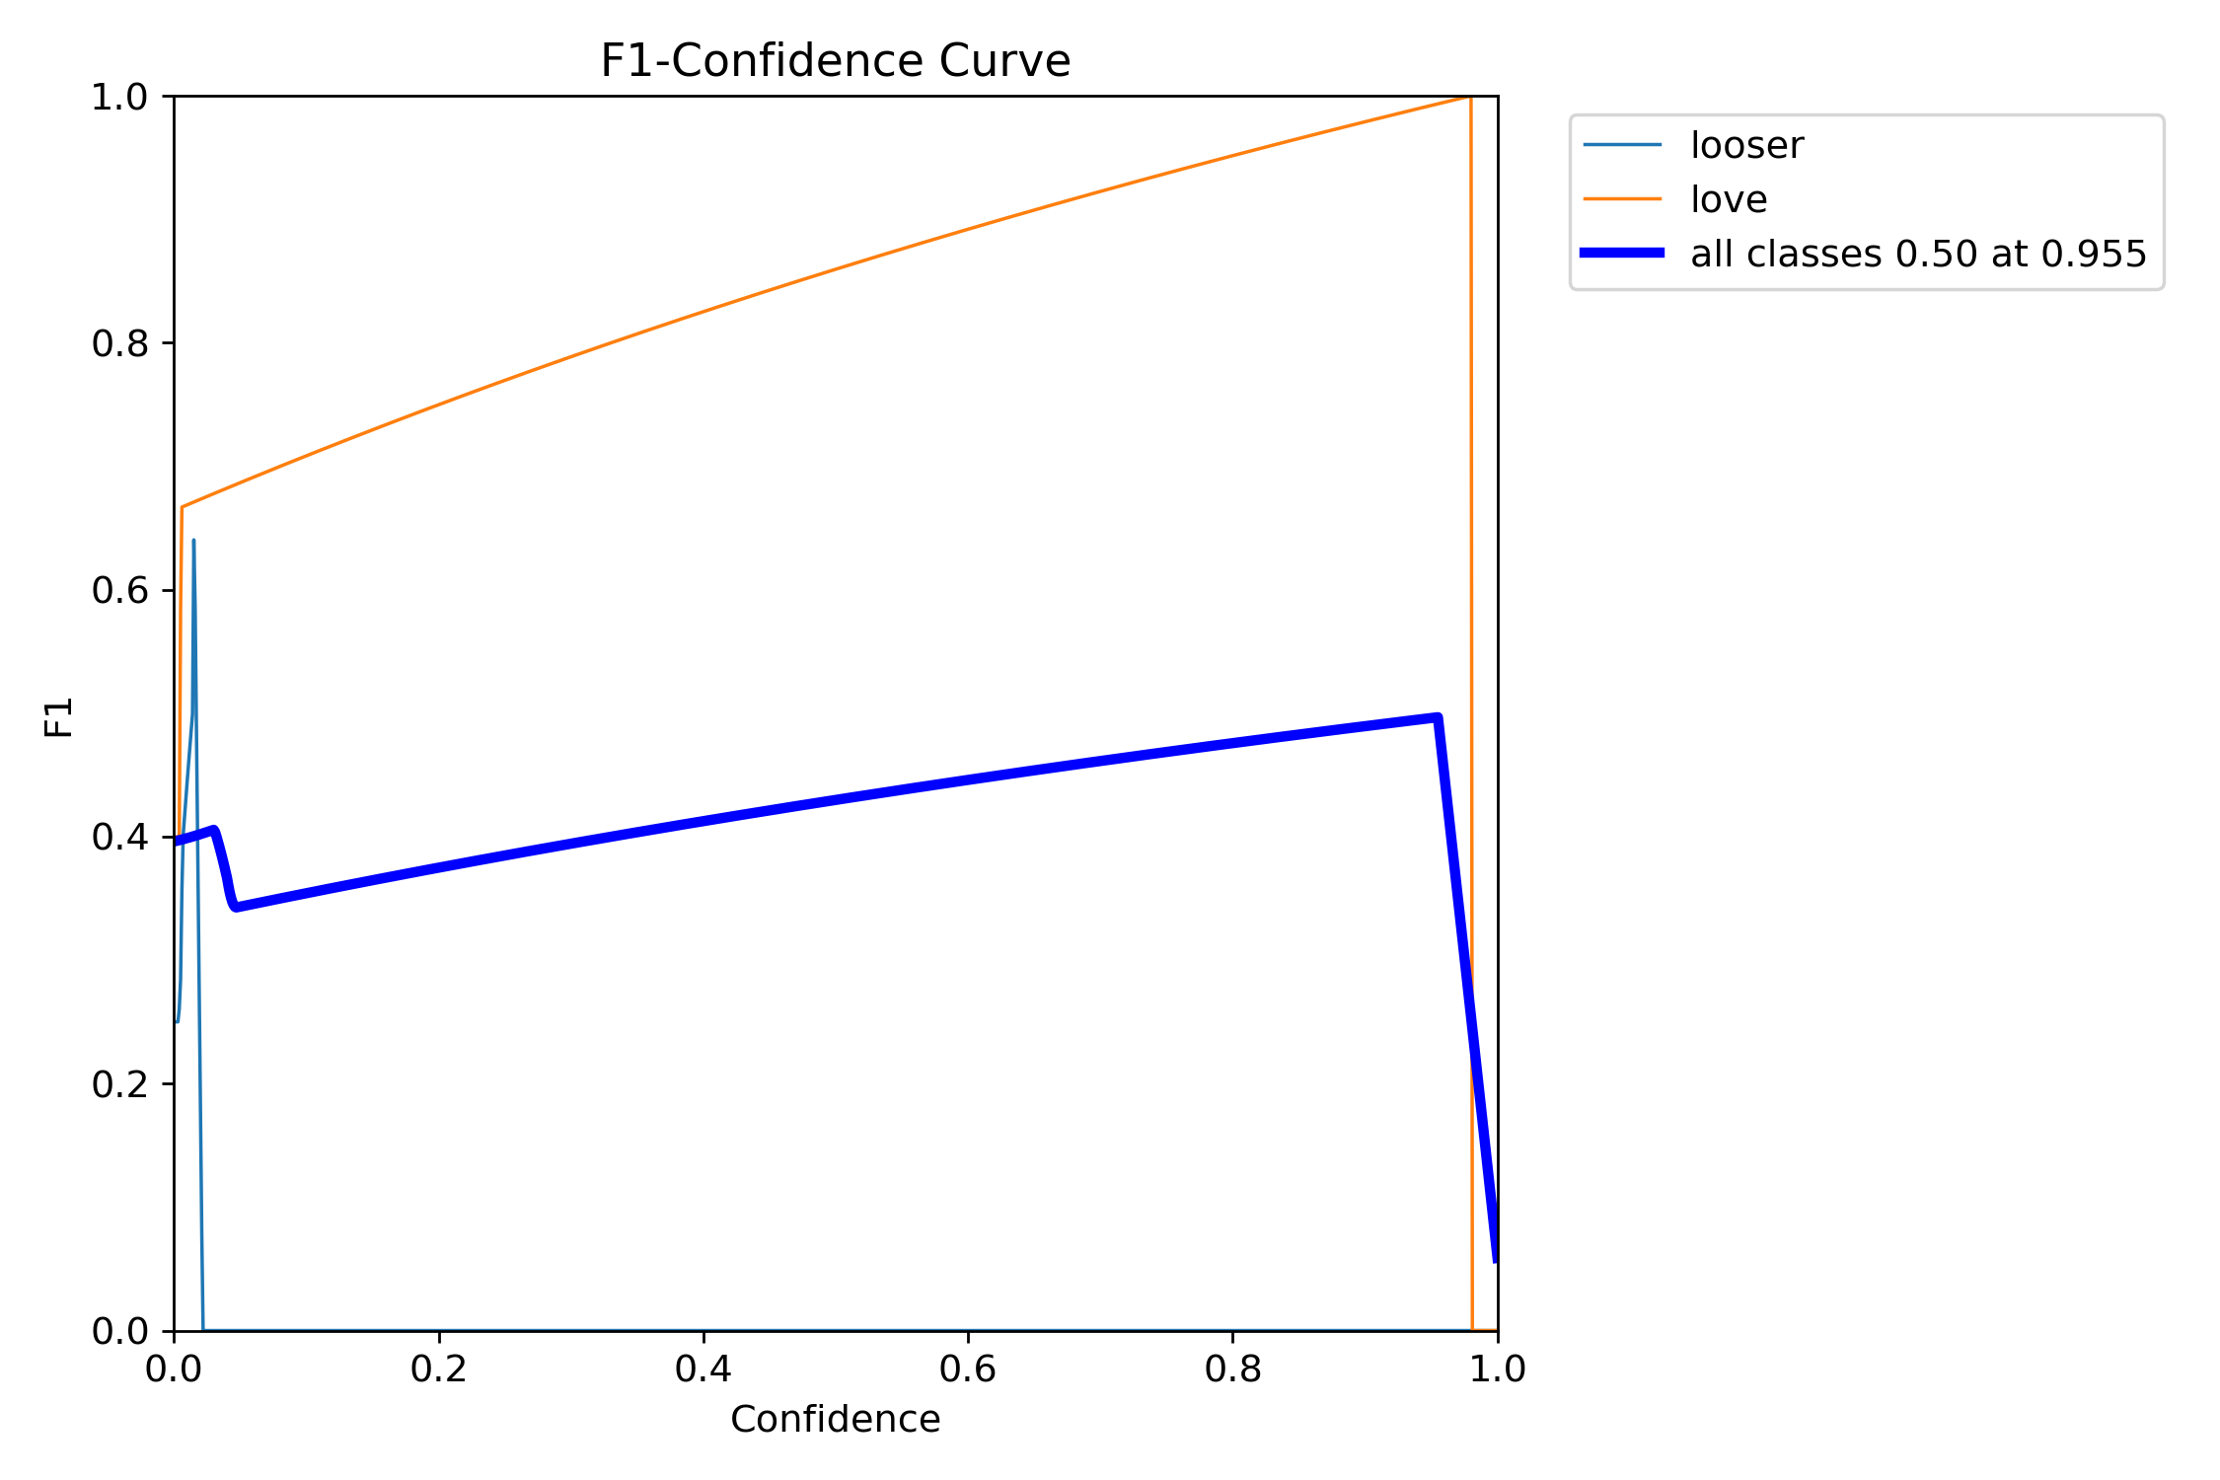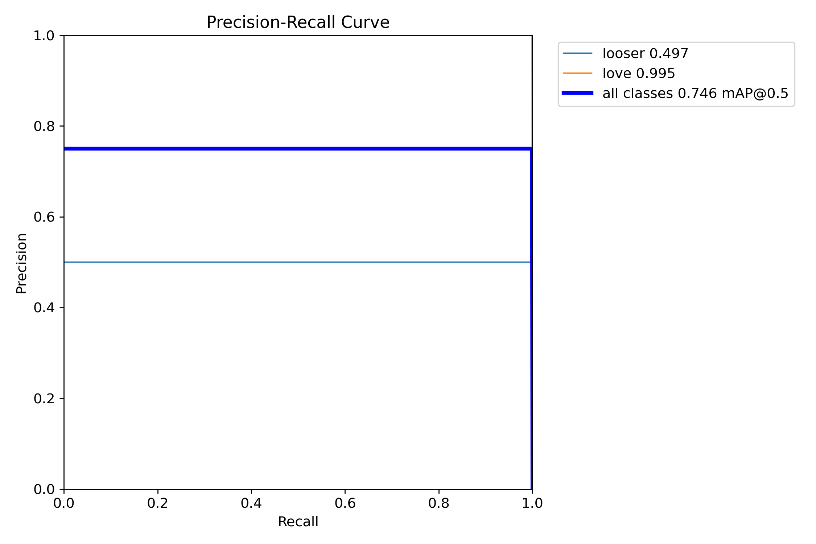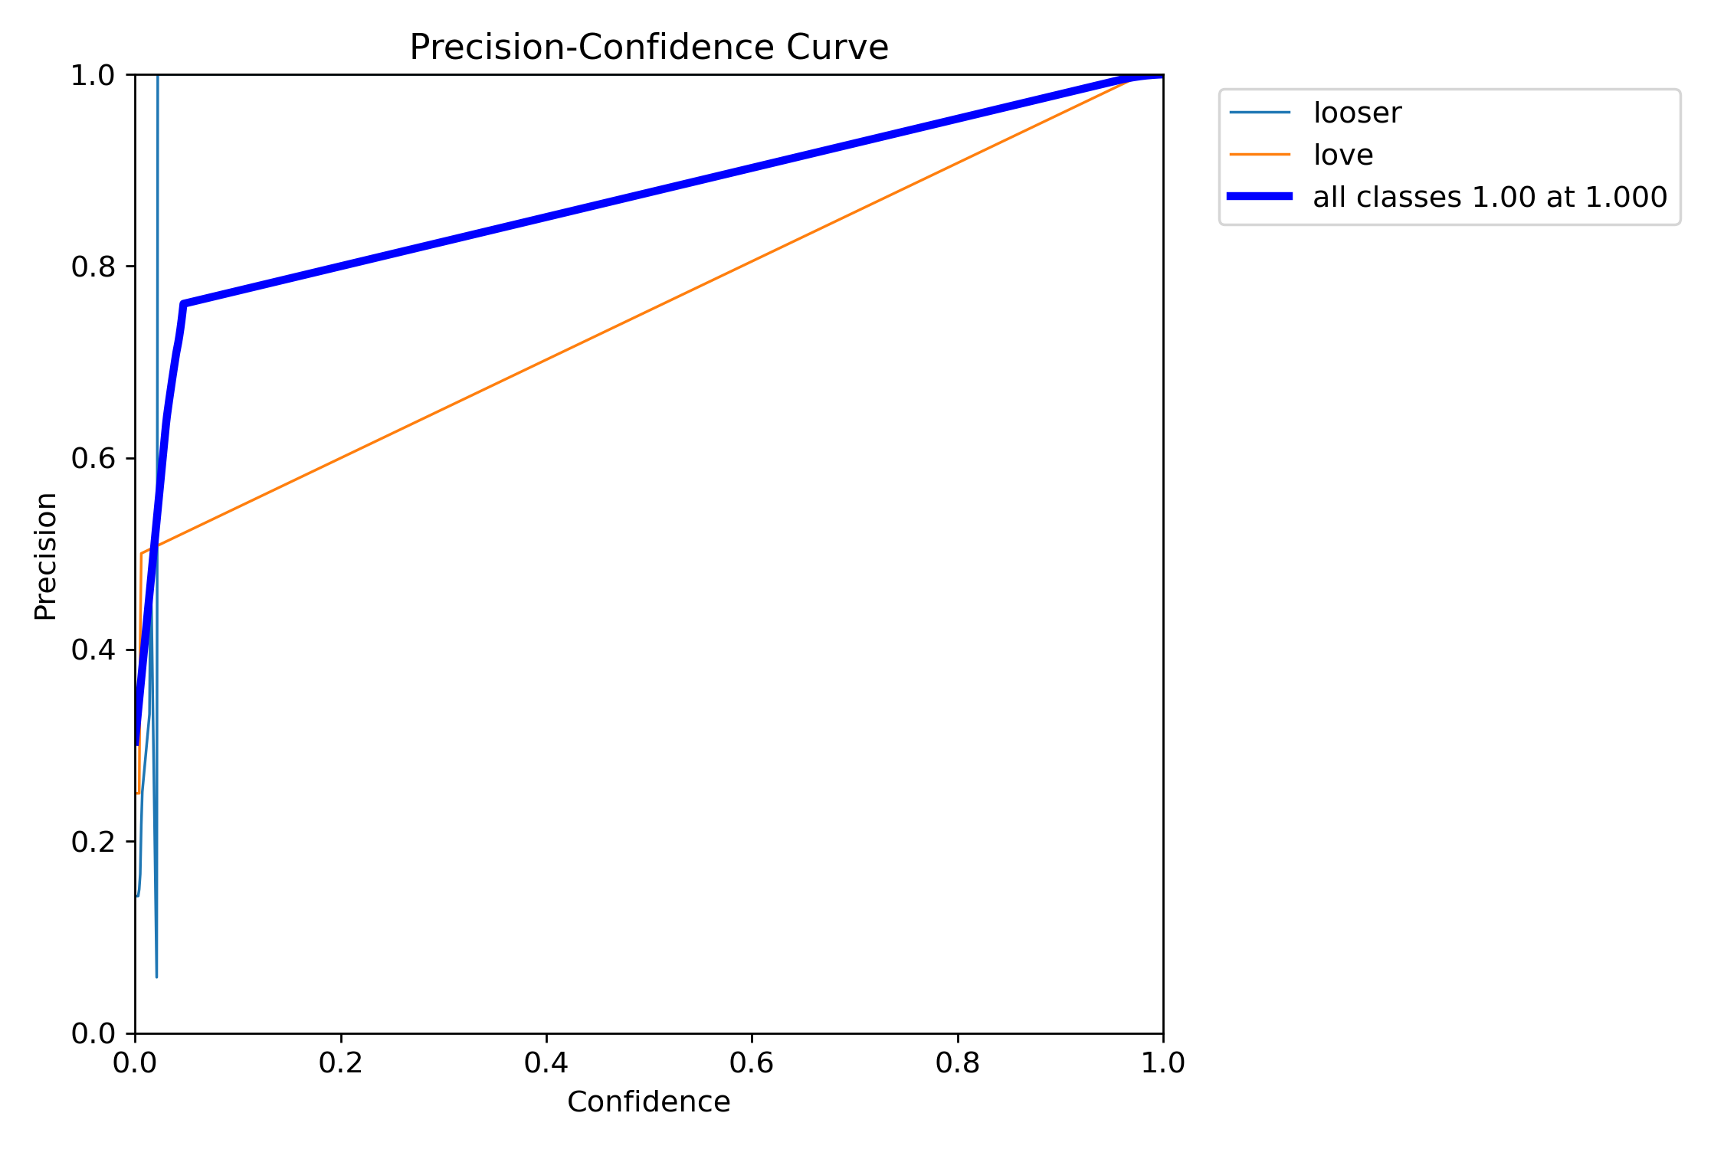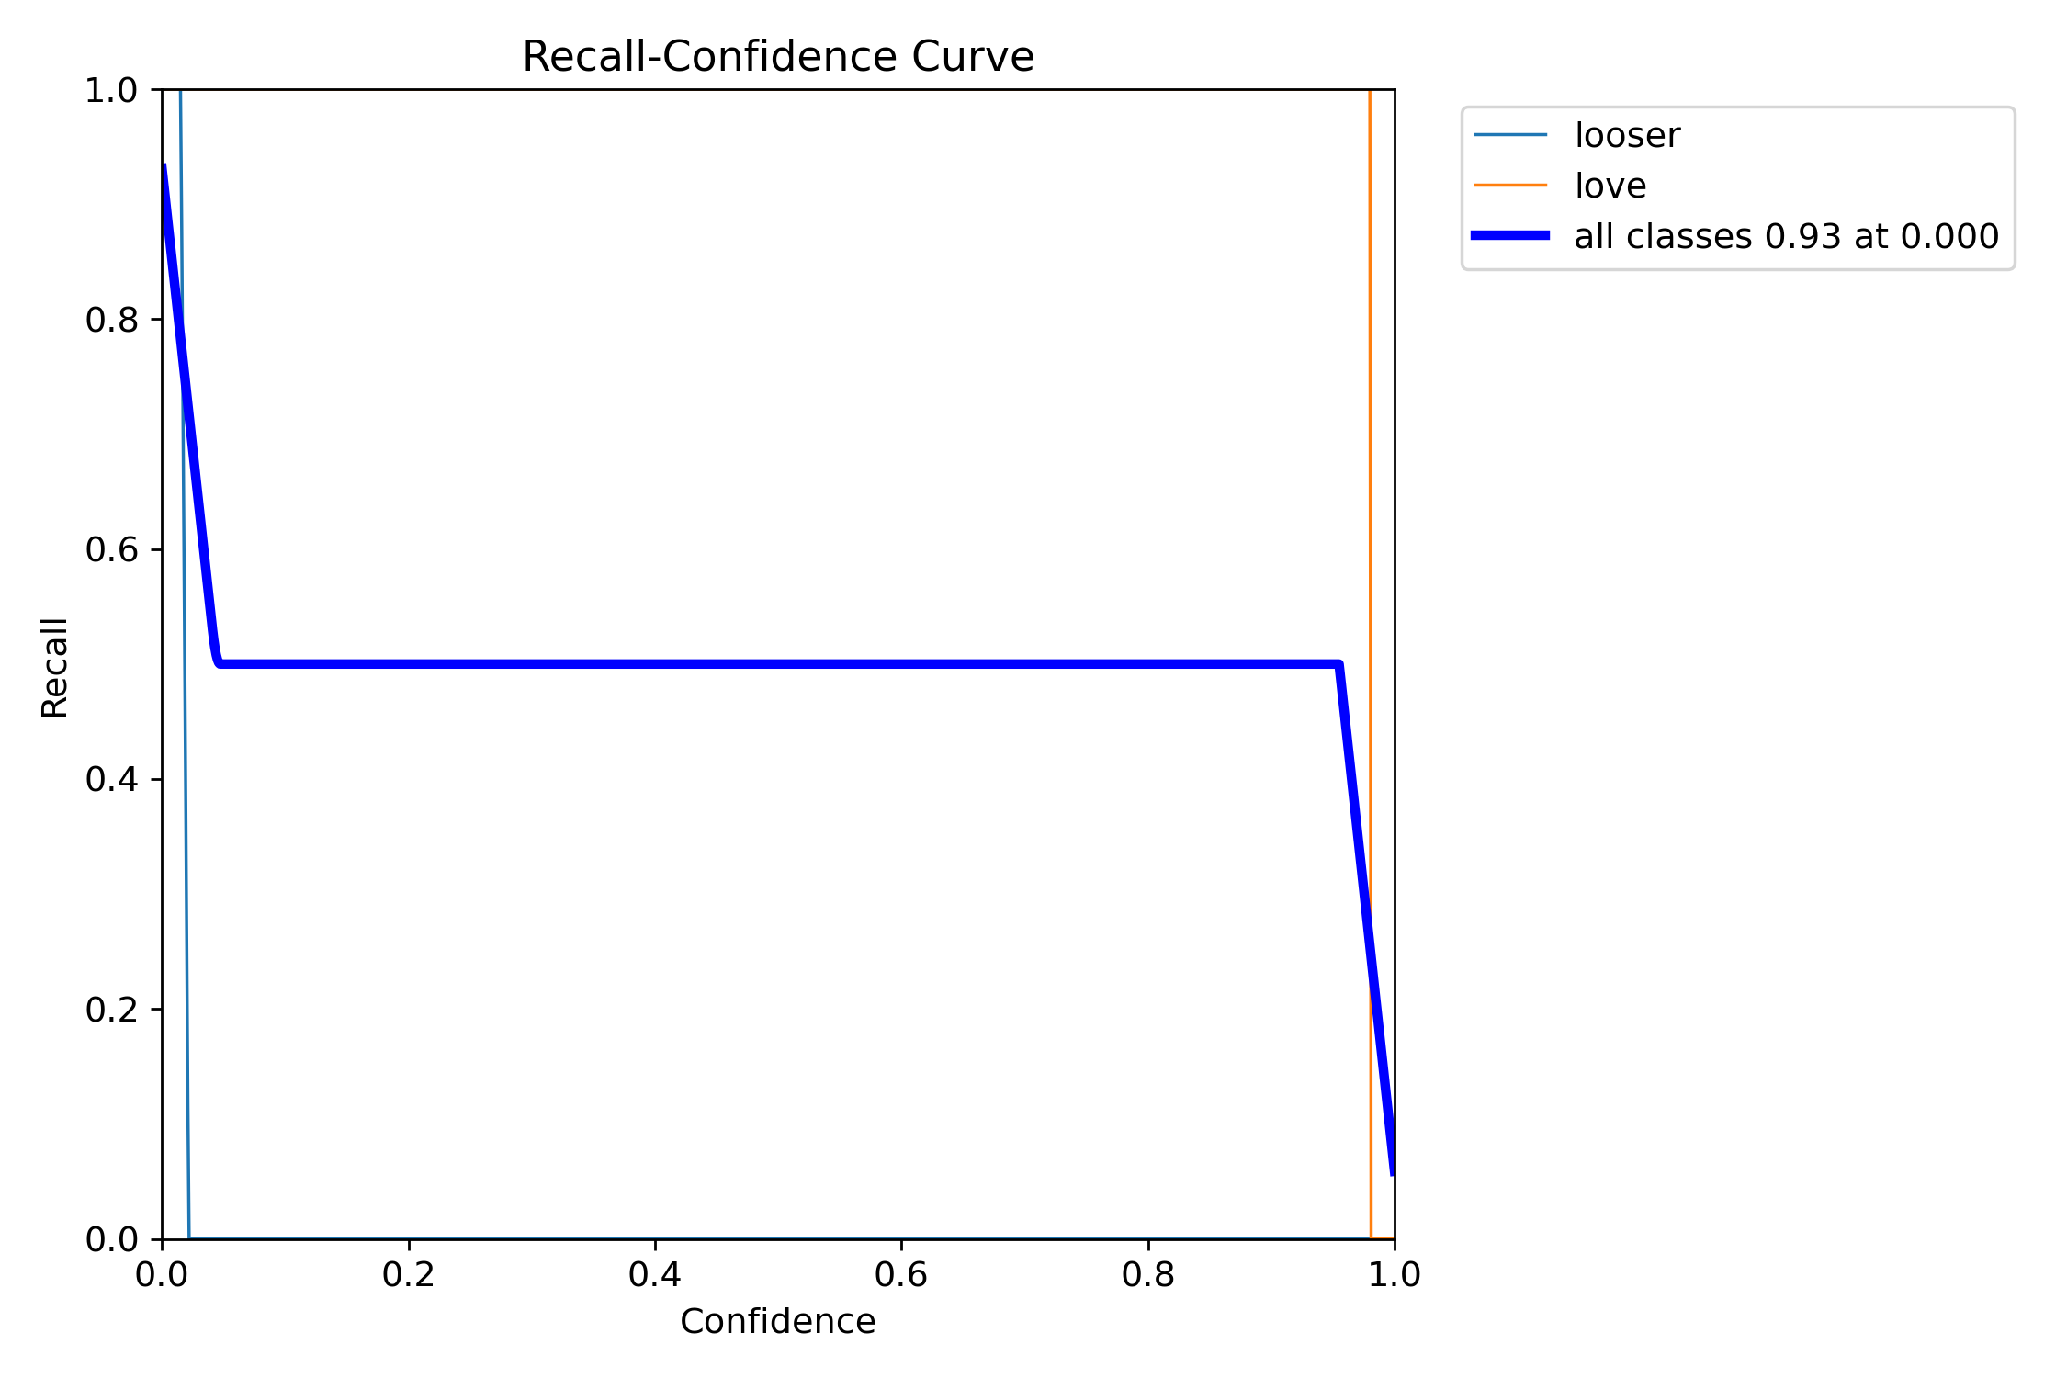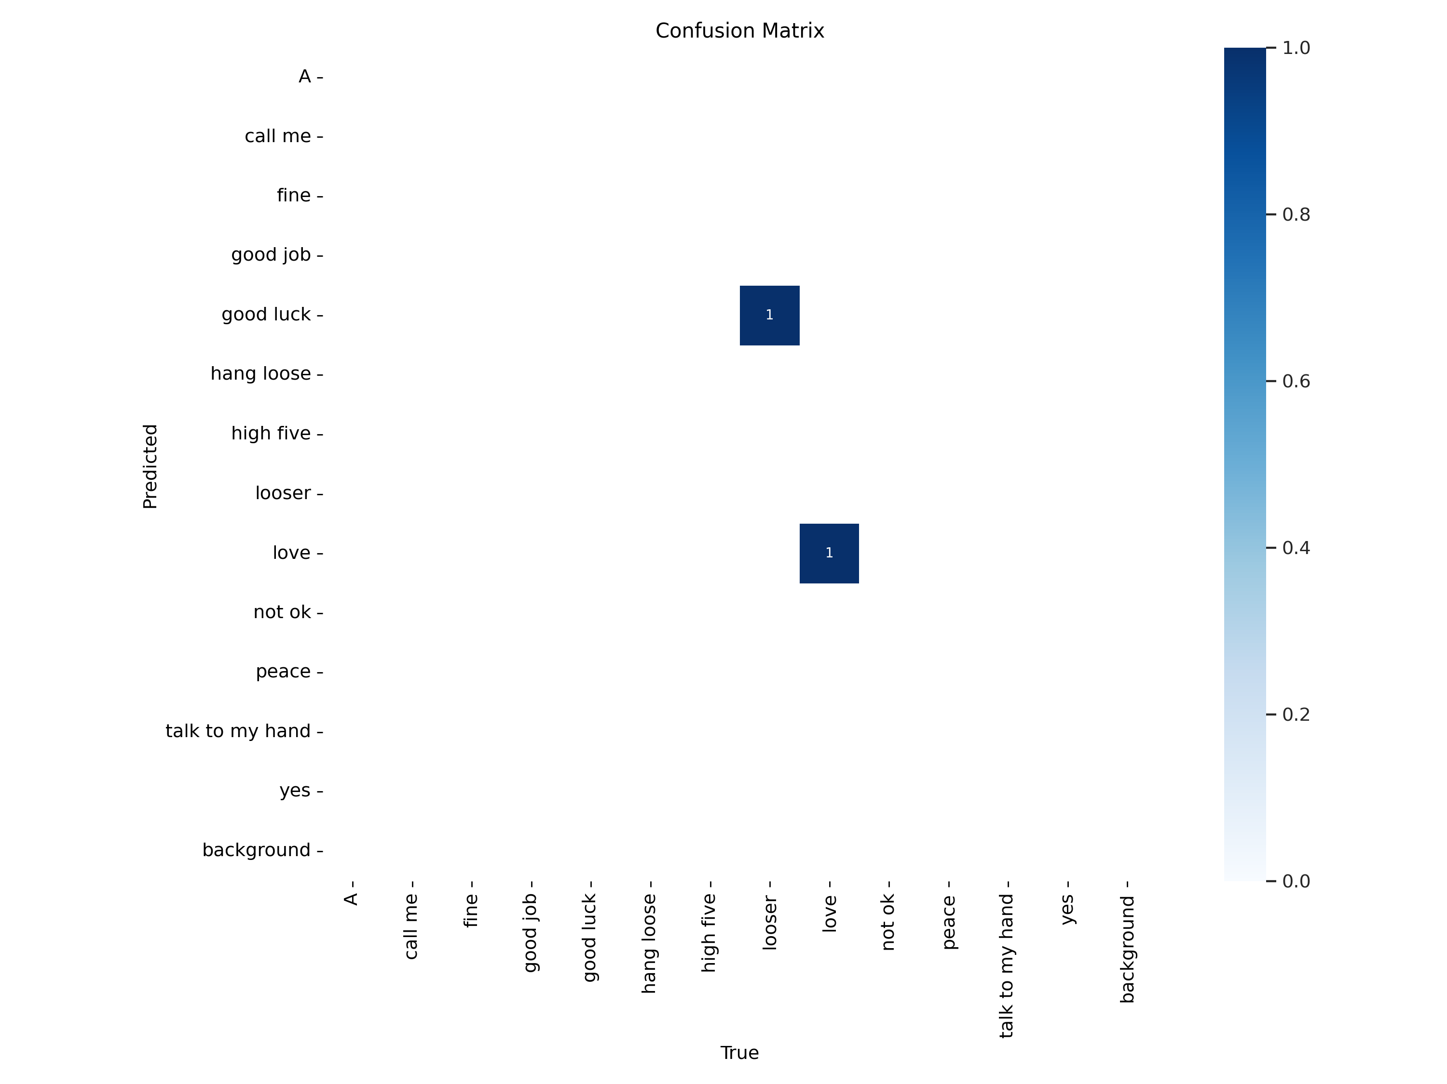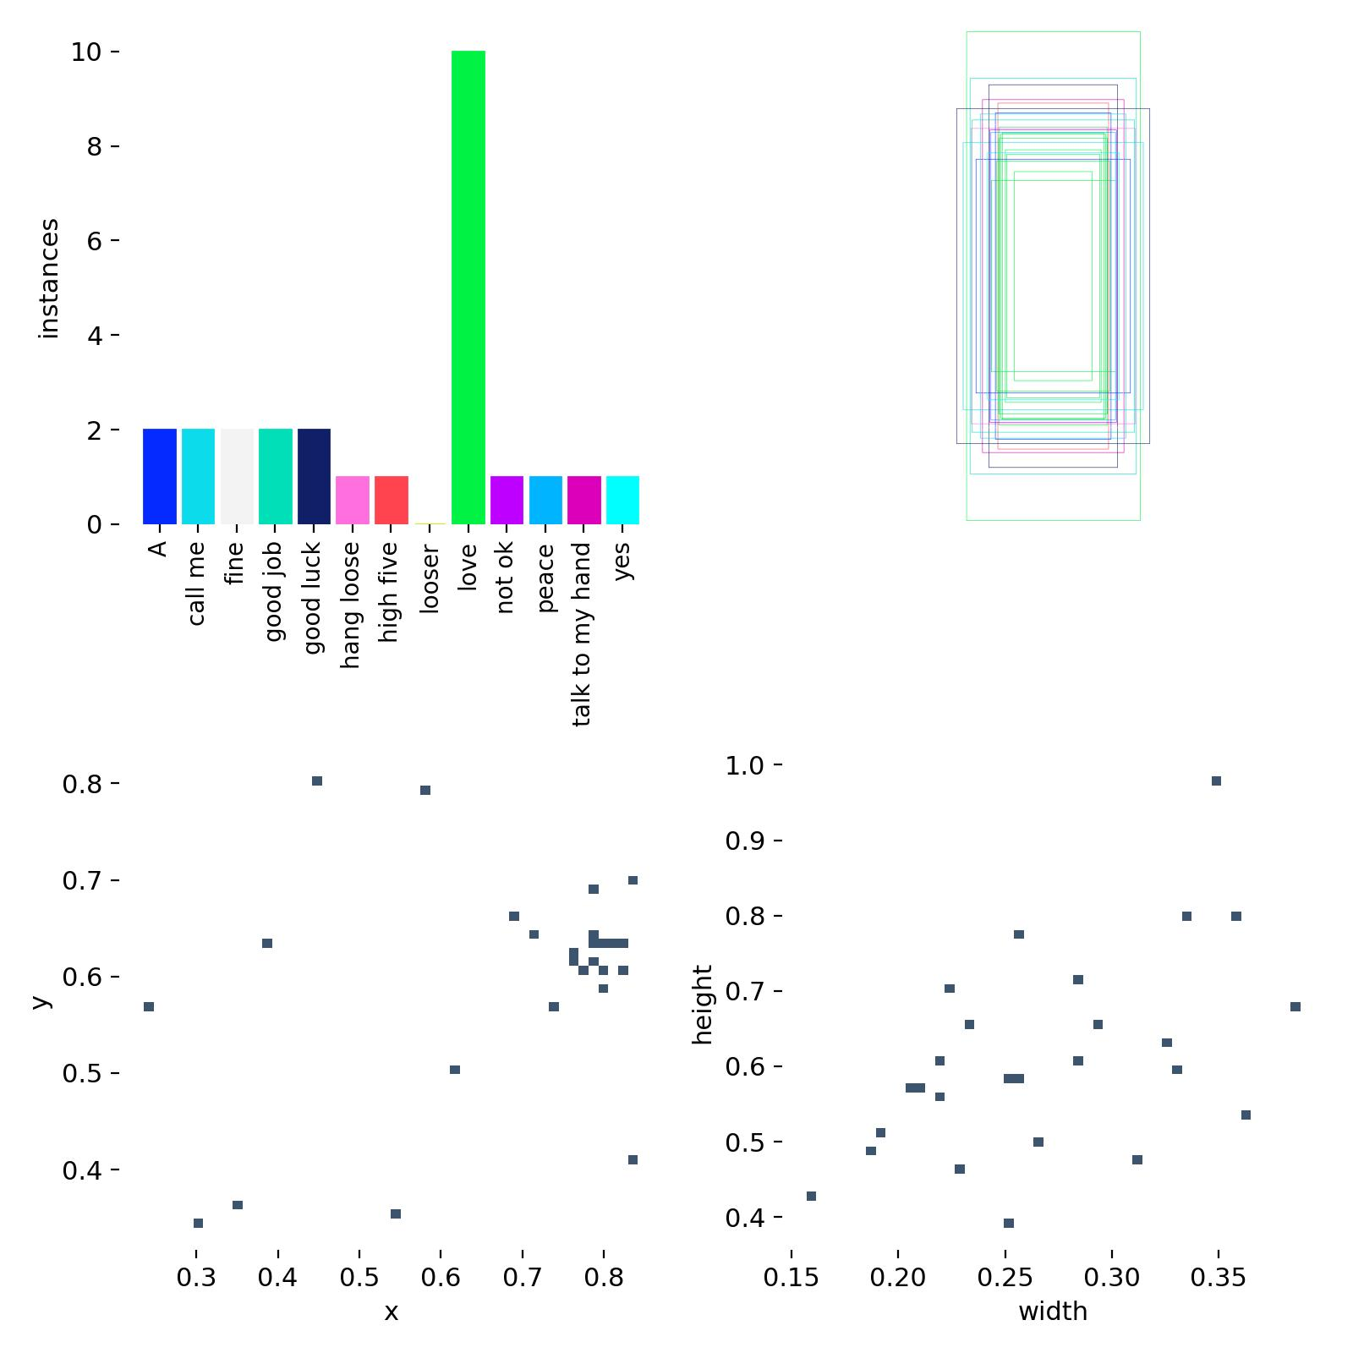



1. FUTURE SCOPE

#### **1. Technological Advancements**

1. **Integration with Augmented Reality (AR)**:
   * Overlay detected sign translations in real-time using AR devices such as smart glasses.
   * Provide visual feedback to assist users in learning and correcting gestures.
2. **Support for Additional Sign Languages**:
   * Expand the system to recognize multiple regional and national sign languages.
   * Use transfer learning to reduce training time for new datasets.
3. **Improved Gesture Recognition**:
   * Implement transformer-based models like Vision Transformers (ViTs) to handle complex and long-range gesture dependencies.
   * Incorporate advanced noise reduction techniques for better performance in challenging environments.
4. **Emotion Recognition**:
   * Integrate emotion detection to add context to gestures, making communication more expressive and accurate.

#### **2. User-Centric Enhancements**

1. **Customizable User Profiles**:
   * Allow users to create profiles with personalized settings for gesture detection speed, language preferences, and output formats.
   * Enable adaptive learning for specific users' signing styles.
2. **Interactive Learning Modules**:
   * Include gamified modules to teach users sign language.
   * Provide real-time feedback on gesture accuracy, helping users learn sign language effectively.
3. **Multi-User Detection**:
   * Extend the system to detect and process gestures from multiple users simultaneously in group settings.
4. **Offline Functionality**:
   * Enable the system to work offline using edge computing, making it accessible in areas with limited internet connectivity.

#### **3. Cross-Platform and IoT Integration**

1. **Mobile and Wearable Devices**:
   * Optimize the system for mobile devices, enabling users to use gesture detection on the go.
   * Integrate with wearables like smartwatches and fitness trackers for gesture-based control.
2. **IoT Integration**:
   * Use gestures to control smart home devices, such as turning on lights or adjusting the thermostat.
   * Integrate with public kiosks to assist individuals with hearing or speech impairments.
3. **Cloud-Connected Systems**:
   * Offer cloud-based storage and processing for large-scale deployments in education and healthcare sectors.
   * Facilitate remote collaboration and communication by syncing detected gestures across devices.

#### **4. Application in Diverse Domains**

1. **Education**:
   * Develop interactive systems for teaching sign language in schools and universities.
   * Use AI-driven feedback to help students practice and refine their gestures.
2. **Healthcare**:
   * Implement in hospitals and clinics to enable effective communication between healthcare providers and patients with hearing impairments.
   * Use gestures for controlling medical devices or accessing patient data.
3. **Workplace and Public Services**:
   * Deploy in workplaces to foster inclusive environments for employees with disabilities.
   * Install gesture-detection systems in public service areas, such as banks or government offices, to assist hearing-impaired users.
4. **Media and Entertainment**:
   * Translate sign language for live events, TV broadcasts, and online content in real-time.
   * Develop games or interactive experiences that use sign gestures as controls.

#### **5. Research Opportunities**

1. **Dynamic Gesture Understanding**:
   * Study complex, continuous signing sequences and improve segmentation of overlapping gestures.
   * Develop models to handle nuanced signing styles, including those involving subtle handshapes or rapid movements.
2. **Sign Language Dialects**:
   * Explore dialectal variations within sign languages and enable detection across diverse linguistic contexts.
3. **Cultural Adaptation**:
   * Incorporate cultural differences in gestures to make the system globally applicable.

#### **6. Social and Accessibility Goals**

1. **Global Accessibility**:
   * Promote universal adoption by ensuring compatibility with low-cost devices.
   * Partner with NGOs and governments to deploy systems in underserved regions.
2. **Advancing Inclusivity**:
   * Encourage societal inclusion by integrating the system into public infrastructures.
   * Create awareness campaigns to educate the general public about the importance of sign language.
3. **Empowering the Deaf Community**:
   * Enable independent communication for individuals with hearing or speech impairments.
   * Provide tools for real-time collaboration and interaction in professional and social settings.

#### **7. Long-Term Vision**

1. **Universal Translator**:
   * Expand the system to serve as a universal translator between spoken and sign languages globally.
   * Integrate multilingual text-to-speech and text-to-sign capabilities.
2. **AI-Driven Improvements**:
   * Use federated learning to update models with user-specific data while maintaining privacy.
   * Employ explainable AI (XAI) techniques to understand and improve gesture recognition algorithms.
3. **Integration with Assistive Robots**:
   * Equip robots with gesture detection capabilities for improved interaction with users.
   * Use robots in settings like caregiving, customer service, and education.

The future scope of this project lies in its potential to evolve beyond a tool for gesture recognition into a universal solution for inclusive communication. By leveraging advancements in AI, IoT, and user-centric design, the system can significantly impact society, empowering individuals and fostering a more inclusive world.

BIBLIOGRAPHY

#### **Books**

1. Goodfellow, I., Bengio, Y., & Courville, A. (2016). Deep Learning. MIT Press.
   * Comprehensive overview of deep learning concepts, including CNNs and RNNs, used for gesture recognition.
2. Bishop, C. M. (2006). Pattern Recognition and Machine Learning. Springer.
   * Discusses the mathematical foundation for machine learning techniques relevant to gesture detection.
3. Chollet, F. (2018). Deep Learning with Python. Manning Publications.
   * Focuses on practical implementations of machine learning, including the Keras library.

#### **Research Papers**

1. Redmon, J., & Farhadi, A. (2018). YOLOv3: An Incremental Improvement. arXiv preprint arXiv:1804.02767.
   * Discusses the YOLO model, its architecture, and its applications in object detection tasks.
2. Simonyan, K., & Zisserman, A. (2014). Very Deep Convolutional Networks for Large-Scale Image Recognition. arXiv preprint arXiv:1409.1556.
   * Basis for CNN architectures used in spatial feature extraction.
3. Vaswani, A., et al. (2017). Attention Is All You Need. Advances in Neural Information Processing Systems.
   * Introduces the Transformer architecture, which can be adapted for gesture recognition tasks.
4. Ghosh, S., et al. (2020). Hand Gesture Recognition Using Deep Learning for Non-Verbal Communication. Procedia Computer Science.
   * Explores the application of deep learning in hand gesture recognition and its societal implications.

#### **Web Resources**

1. TensorFlow Documentation. Available at: <https://www.tensorflow.org>
   * Guides on implementing machine learning models and YOLO integrations.
2. PyTorch Documentation. Available at: <https://pytorch.org>
   * Useful for creating and training deep learning models used in sign language detection.
3. Roboflow: Dataset Management and Annotation. Available at: <https://roboflow.com>
   * Provides tools for data annotation, augmentation, and formatting for YOLO models.
4. OpenCV Documentation. Available at: <https://opencv.org>
   * Essential for video preprocessing and real-time image processing tasks.
5. Ultralytics YOLO Documentation. Available at: <https://github.com/ultralytics/yolov5>
   * Offers insights and code examples for implementing YOLO in object detection projects.

#### **Datasets**

1. American Sign Language Dataset. Available at: <https://www.kaggle.com>
   * Provides labeled datasets for training and testing sign language models.
2. MSCOCO Dataset. Available at: <https://cocodataset.org>
   * Used for general object detection tasks, often adapted for gesture recognition.
3. OpenSign Database. Available at: <https://opensign.org>
   * A large collection of annotated sign language videos.

#### **Standards and Regulations**

1. General Data Protection Regulation (GDPR). Available at: <https://gdpr-info.eu>
   * Guidelines for managing user data securely.
2. Americans with Disabilities Act (ADA). Available at: <https://www.ada.gov>
   * Legal framework for ensuring accessibility for individuals with disabilities.